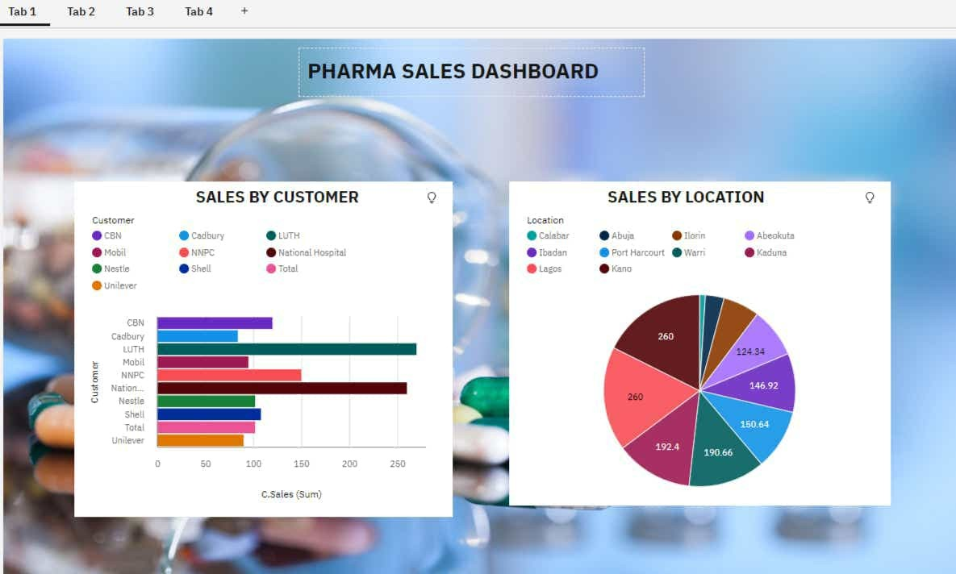

ASSIGNMENT 2

Pharma Sales Dashboard

|  |  |
| --- | --- |
| DATE | 24.09.2022 |
| STUDENT NAME | M.VISHALI |
| STUDENT ROLL NO | 2019PITIT161 |
|  |  |

